Descriptions and example outputs for files:

**ElasticEnergyTester3.m**

* Finds total elastic energy in a bent OMCR
* Notable parameters:
  + Num_segments: number of segments
  + EI: bending stiffness per segment
  + Lengths of segments
  + Internal angles for each segment
* Assumes uniform bending and no complex internal forces

Example output

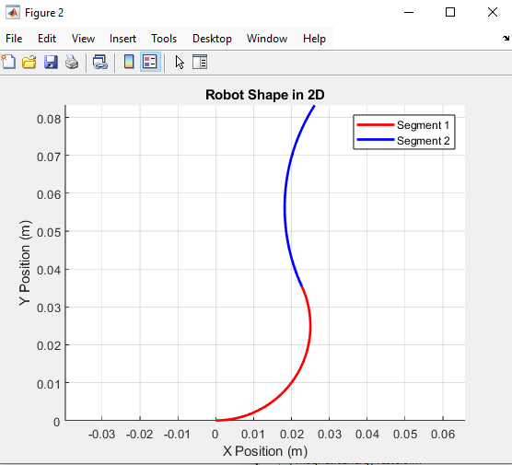

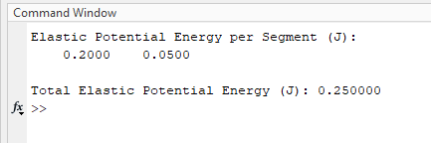

**MagneticEnergyTester3.m**

Gets total magnetic potential energy in the system

Starting parameters:

* Dipole moment of the external magnitude
* Lengths of tubes

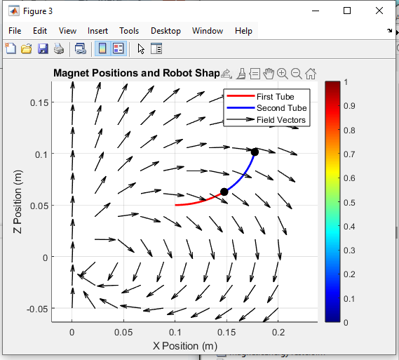

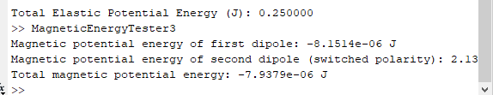

**TotalEnergyTest.m**

Combines magnetic and elastic energy testing procedures

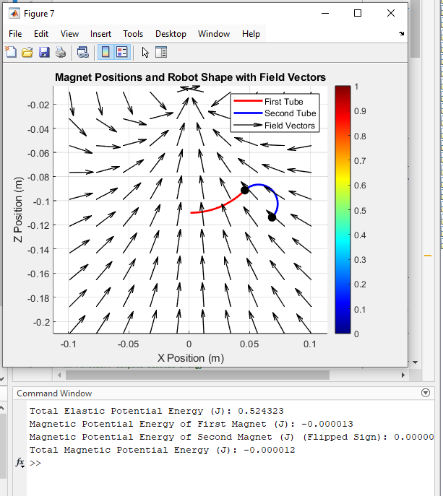

**LocalMinsTester.m**

Reimplements procedures from MagneticEnergyTester3 and EleasticEnergyTester3, now using them to find total energy, and the most intuitive local minimum thereof.

Starting parameters:

* Number of segments (I’ve only ever tried 2 segments)
* Bending stiffness per segment
* Internal magnet dipole moment (was calculated from magnet data sheet)
* External magnet dipole moment (calculated in dipole script, see other folder)
* Initial robot stem angle
* Initial positions for internal magnet angles
* Lengths of segments

Uses fminunc to find the natural equilibrium from a certain start position, assuming no change in stem position or angle.

Outputs

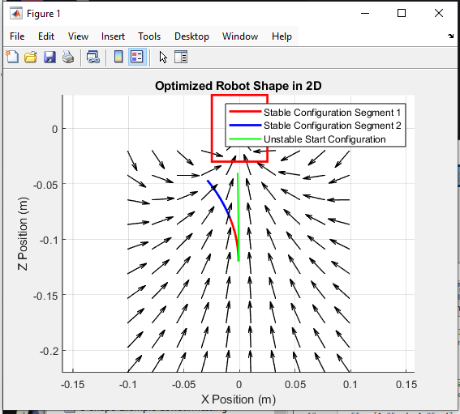

**CallableMinsTester.m**

* Does the same thing as LocalMinsTester, but makes it callable from other functions

Inputs:

* start_angle: Stem angle
* ptart_pos Stem position
* theta1_0: starting internal angle 1
* theta2_0: start internal angle 2
* do_plot: bool for if we want to draw the current position
  + Doesn’t close the drawing, meaning over multiple calls we get multiple overlaid drawings
* iteration: current iteration
* max_iteration: checks with current iteration to know if we should close the drawing

**PathFinder3.m**

* Attempts to find pathing from an initial starting position, to an end starting Shape

Notable start parameters:

* Start_angle: angle of stem
* Start_pos: stem position
* theta_current: angles for internal magnets at start
* target_theta: goal end theta

This program repeatedly makes small increments (can be changed) in all directions and in both rotations, and calls callableminstester.m to check which brings us closest to our goal. Then repeat. If it runs into a dead end, we do a random perturbation and keep going.

Output example:

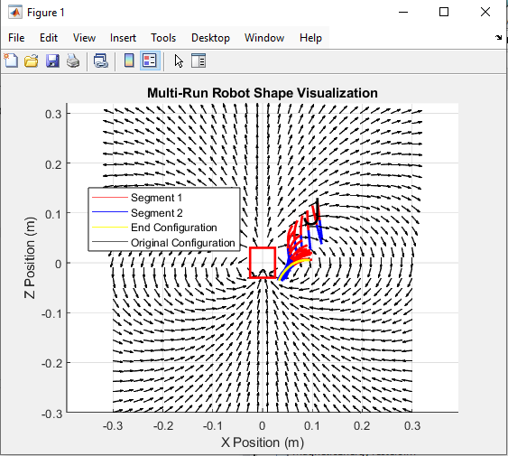

**EnergyVisualizer.m**

Generates a 3D Plot of the total potential energy over the angles of internal magnets

* Makes a grid, repeatedly calls callableminstester.m, then plots it

Great for seeing stable configurations from a specific stem position and angle

Notable parameters:

* Stem position (start_x, start_y) and angle (start_angle)
* Bending stiffness per section
* Length per section
* Magnetic dipoles for big magnet an internal magnets
* Range of angles to include

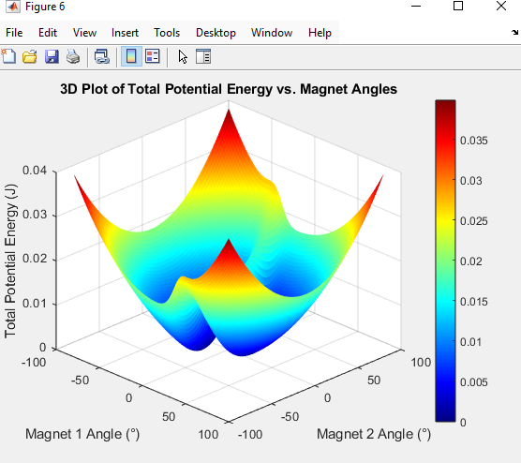

Still in progress:

* Visualization of bifurcation points.
* Goal: show points between start positions that will lead to different stable configurations
  + Makes a grid, checks the end position for its stable configuration; checks if each position has neighbors that go to a different stable configuration.
  + Idea: we can use this to find minimum perturbation to permanently change the current configuration
  + Doesn’t really work all that well

